MAUNDY THURSDAY - April 6, 2023
7:00 PM - Service of Holy Communion
Beginning of the Three Days of Holy Week in the Christian Church

Shared by: Evangelical Lutheran, Durham – Bridge Pastor James Heckman
St Luke’s, Ferndale – Pastor Richard Bergen
Trinity Lutheran, Pleasant Valley - Pastor Kathleen Harkness

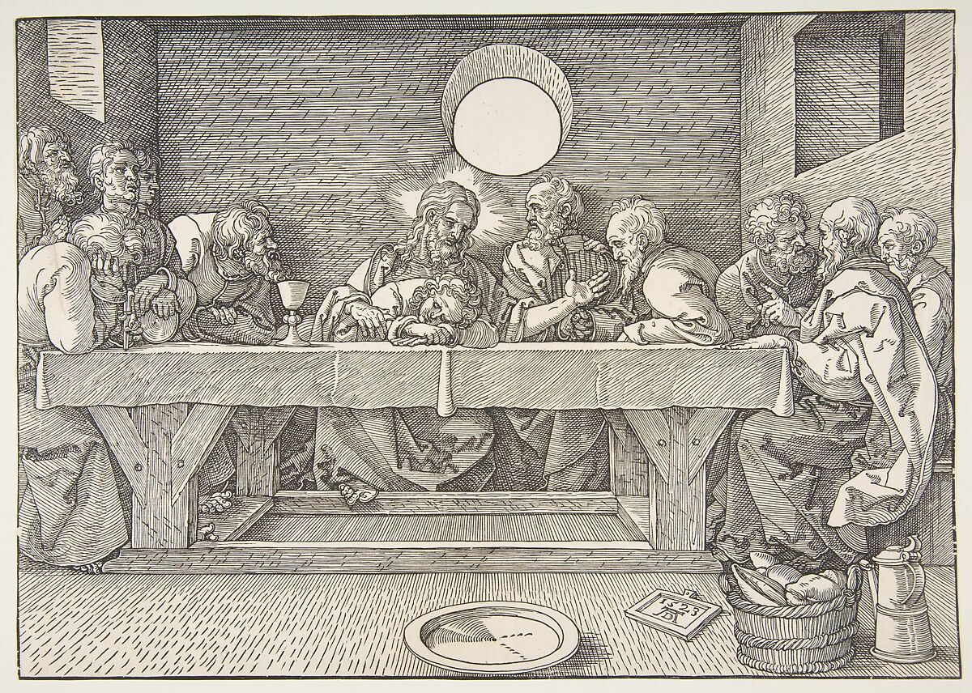

Introduction to Worship
This evening our Lenten observance comes to an end, and we gather with Christians around the world to celebrate the Three Days of Jesus’ death and resurrection. Tonight we remember Christ’s last meal with his disciples, but the central focus is his commandment that we live out the promise embodied in this meal. As Jesus washed his disciples’ feet, so we are called to give and receive love in humble service to one another. Formed into a new body in Christ through this holy meal, we are transformed by the mercy we have received and carry it into the world. Departing worship in solemn silence, we anticipate the coming days.

You can find the live stream at the following locations:
www.youtube.com/@DurhamLutheran
Worship from Sundays and Seasons.com. Copyright 2015 Augsburg Fortress. All rights reserved. Reprinted by permission under Augsburg Fortress Liturgies Annual License #SB170076.
Permission to podcast/stream the music in this service obtained from ONE LICENSE, License # 715933-A. All rights reserved.
GATHERING -- Prelude -- Carolyn Williams
Confession and Forgiveness
Friends in Christ, in this Lenten season we have heard our Lord’s call to struggle against sin, death, and the devil—all that keeps us from loving God and each other. This is the struggle to which we were called at baptism.
Within the community of the church, God never wearies of forgiving sin and giving the peace of reconciliation. On this night let us confess our sin against God and our neighbor, and enter the celebration of the great Three Days reconciled with God and with one another.
P: Most merciful God,
C: we confess that we are captive to sin and cannot free ourselves. We have sinned against you in thought, word, and deed, by what we have done and by what we have left undone. We have not loved you with our whole heart; we have not loved our neighbors as ourselves. For the sake of your Son, Jesus Christ, have mercy on us. Forgive us, renew us, and lead us, so that we may delight in your will and walk in your ways, to the glory of your holy name. Amen.
P: God, who is rich in mercy, loved us even when we were dead in sin, and made us alive together with Christ. By grace you have been saved. In the name of ☩ Jesus Christ, your sins are forgiven. Almighty God strengthen you with power through the Holy Spirit, that Christ may live in your hearts through faith.
C: Amen.
INDIVIDUAL ABSOLUTION (if desired – come forward to either pastor)
P: In obedience to the command of our Lord Jesus Christ, I forgive you all your sins.
C: Amen.
(Please Stand)

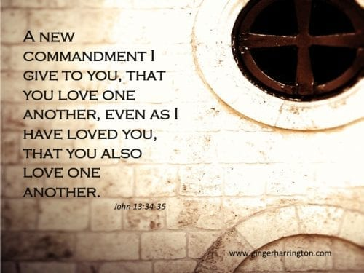

Greeting
P: The grace of our Lord Jesus Christ, the love of God, and the communion of the Holy Spirit be with you all.
C: And also with you.
Prayer of the Day
P: Holy God, source of all love, on the night of his betrayal, Jesus gave us a new commandment, to love one another as he loves us. Write this commandment in our hearts, and give us the will to serve others as he was the servant of all, your Son, Jesus Christ, our Savior and Lord, who lives and reigns with you and the Holy Spirit, one God, now and forever.
C: Amen. (Congregation is seated after prayer.)

First Reading -- Exodus 12:1-4, 11-14
Israel remembered its deliverance from slavery in Egypt by celebrating the festival of Passover. This festival featured the Passover lamb, whose blood was used as a sign to protect God’s people from the threat of death. The early church described the Lord’s supper using imagery from the Passover, especially in portraying Jesus as the lamb who delivers God’s people from sin and death.
L: A reading from Exodus
¹The Lord said to Moses and Aaron in the land of Egypt: ²This month shall mark for you the beginning of months; it shall be the first month of the year for you. ³Tell the whole congregation of Israel that on the tenth of this month they are to take a lamb for each family, a lamb for each household. ⁴If a household is too small for a whole lamb, it shall join its closest neighbor in obtaining one; the lamb shall be divided in proportion to the number of people who eat of it. ¹¹This is how you shall eat it: your loins girded, your sandals on your feet, and your staff in your hand; and you shall eat it hurriedly. It is the passover of the Lord. ¹²For I will pass through the land of Egypt that night, and I will strike down every firstborn in the land of Egypt, both human beings and animals; on all the gods of Egypt I will execute judgments: I am the Lord. ¹³The blood shall be a sign for you on the houses where you live: when I see the blood, I will pass over you, and no plague shall destroy you when I strike the land of Egypt.
¹⁴This day shall be a day of remembrance for you. You shall celebrate it as a festival to the Lord; throughout your generations you shall observe it as a perpetual ordinance.
Psalm Verse -- Psalm 116:1-2, 12-19
I will lift the cup of salvation and call on the name of the Lord. (Ps. 116:13)
L: ¹I love the Lord, who has heard my voice, and listened to my supplication,
C: ²for the Lord has given ear to me whenever I called.
L: ¹²How shall I repay the Lord for all the good things God has done for me?
C: ¹³I will lift the cup of salvation and call on the name of the Lord.
L: ¹⁴I will fulfill my vows to the Lord in the presence of all God’s people.
C: ¹⁵Precious in your sight, O Lord, is the death of your servants.
L: ¹⁶O Lord, truly I am your servant; I am your servant, the child of your handmaid; you have freed me from my bonds.
C: ¹⁷I will offer you the sacrifice of thanksgiving and call upon the name of the Lord.
L: ¹⁸I will fulfill my vows to the Lord in the presence of all God’s people,
C: ¹⁹in the courts of the Lord’s house, in the midst of you, O Jerusalem.
Second Reading -- 1 Corinthians 11:23-36
In the bread and cup of the Lord’s supper, we experience intimate fellowship with Christ and with one another because it involves his body given for us and the new covenant in his blood. Faithful participation in this meal is a living proclamation of Christ’s death until he comes in the future.
L: A reading from 1 Corinthians:
²³For I received from the Lord what I also handed on to you, that the Lord Jesus on the night when he was betrayed took a loaf of bread, ²⁴and when he had given thanks, he broke it and said, “This is my body that is for you. Do this in remembrance of me.” ²⁵In the same way he took the cup also, after supper, saying, “This cup is the new covenant in my blood. Do this, as often as you drink it, in remembrance of me.” ²⁶For as often as you eat this bread and drink the cup, you proclaim the Lord’s death until he comes.
Gospel Acclamation
C: I give you a new commandment, that you love one another as I have loved you.
Gospel -- John 13:1-17, 31b-35 (Congregation is seated after the Gospel.)
The story of the last supper in John’s gospel recalls a remarkable event not mentioned elsewhere: Jesus performs the duty of a slave, washing the feet of his disciples and urging them to do the same for one other.

P: A reading from the Gospel of John:
¹Now before the festival of the Passover, Jesus knew that his hour had come to depart from this world and go to the Father. Having loved his own who were in the world, he loved them to the end. ²The devil had already put it into the heart of Judas son of Simon Iscariot to betray him. And during supper ³Jesus, knowing that the Father had given all things into his hands, and that he had come from God and was going to God, ⁴got up from the table, took off his outer robe, and tied a towel around himself. ⁵Then he poured water into a basin and began to wash the disciples’ feet and to wipe them with the towel that was tied around him. ⁶He came to Simon Peter, who said to him, “Lord, are you going to wash my feet?” ⁷Jesus answered, “You do not know now what I am doing, but later you will understand.” ⁸Peter said to him, “You will never wash my feet.” Jesus answered, “Unless I wash you, you have no share with me.” ⁹Simon Peter said to him, “Lord, not my feet only but also my hands and my head!” ¹⁰Jesus said to him, “One who has bathed does not need to wash, except for the feet, but is entirely clean. And you are clean, though not all of you.” ¹¹For he knew who was to betray him; for this reason he said, “Not all of you are clean.”
¹²After he had washed their feet, had put on his robe, and had returned to the table, he said to them, “Do you know what I have done to you? ¹³You call me Teacher and Lord—and you are right, for that is what I am. ¹⁴So if I, your Lord and Teacher, have washed your feet, you also ought to wash one another’s feet. ¹⁵For I have set you an example, that you also should do as I have done to you. ¹⁶Very truly, I tell you, servants are not greater than their master, nor are messengers greater than the one who sent them. ¹⁷If you know these things, you are blessed if you do them.”
^{31b}“Now the Son of Man has been glorified, and God has been glorified in him. ³²If God has been glorified in him, God will also glorify him in himself and will glorify him at once. ³³Little children, I am with you only a little longer. You will look for me; and as I said to the Jews so now I say to you, ‘Where I am going, you cannot come.’ ³⁴I give you a new commandment, that you love one another. Just as I have loved you, you also should love one another. ³⁵By this everyone will know that you are my disciples, if you have love for one another.”
Message

Hand Washing
On this night we have heard our Lord’s commandment to love one another as he has loved us. We who receive God’s love in Jesus Christ are called to love one another, to be servants to each other as Jesus became our servant. Our commitment to this loving service is signified in the washing of hands, following the example our Lord gave us on the night before his death.
The ministers and people may wash each other’s hands.
Prayers of Intercession
P: You make a new covenant with your people. Gather your church around word and table in love and promise as these three holy days enfold us. Open us to behold the mystery of our salvation. Merciful God,
A brief silence.
P: You give us our daily bread, fruit of the earth and work of human hands. Bless those who labor and tend to their crops and those who prepare our meals. Strengthen us to advocate for food justice and a fair distribution of resources. Merciful God,
C: hear our prayer.
P: You, our Savior and Teacher, stoop down to us in servant love. Inspire national and local leaders (especially) with a renewed sense of public service. Increase in them a humility to serve with equity and fairness. Teach us to pray for our enemies. Merciful God,
C: hear our prayer.
P: You incline your ear to us in every need. Befriend all who are lonely. Comfort those who grieve. Soothe any who are anxious. Console all who are distressed. Graciously tend to the hurts of your children who suffer in body, mind, and spirit (especially). Merciful God,
C: hear our prayer.
P: You inspire your people to praise in word, song, and art. We give thanks for artists whose gifts enrich the church’s worship. Kindle in us appreciation for all who beautify our worship space throughout the changing seasons. Merciful God,
C: hear our prayer.
Here other intercessions may be offered.
P: Precious in your sight is the death of your faithful ones. We remember and give thanks for the those who have died (especially). With them, we trust your promise to love your own until the end. Merciful God,
C: hear our prayer.
P: We lift our prayers to you, O God, trusting in your steadfast love and your promise to renew your whole creation; through Jesus Christ our Savior.
C: Amen.

Peace (All share the sign of Christ’s peace with each other.)
The peace of Christ be with you always.
And also with you.

Joint Choir Anthem - ”Lord, Make Us Worthy” - Natalie Sleeth

Offertory Song (Please stand if able.)
Offering Prayer
P: God of good gifts, receive these and all our offerings as we present them in faithful service for the sake of your gospel. Prepare our hearts to receive you in this meal as you pour out your very presence through Christ Jesus, the wellspring of eternal life.
C: Amen.
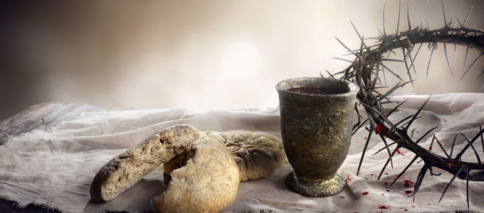
The Great Thanksgiving
Preface for the Passion (Sung by the Presiding Minister.)
“Sanctus” (Sung by the Congregation.)
Jesus’ Words of Institution (Said by the Presiding Minister.)

Lord’s Prayer (Congregation says in unison.)
C: Our Father, who art in heaven, hallowed be thy name, thy kingdom come, thy will be done, on earth as it is in heaven. Give us this day our daily bread; and forgive us our trespasses, as we forgive those who trespass against us; and lead us not into temptation, but deliver us from evil. For thine is the kingdom, and the power, and the glory, forever and ever. Amen.
Invitation to Communion: “Come and receive Jesus, our strength in the wilderness.”
All worshipers are invited to come to the table of the Lord, following the instructions of the ushers.
Hymns during Distribution of Holy Communion
Prayer After Communion
P: Lord Jesus, in a wonderful sacrament you strengthen us with the saving power of your suffering, death, and resurrection. May this sacrament of your body and blood so work in us that the fruits of your redemption will show forth in the way we live, for you live and reign with the Father and the Holy Spirit, one God, now and forever.
C: Amen.
(Congregation remains seated)
Stripping of the Altar.
(Silence for reflection. Congregation may be seated)
P: After the Last Supper, less than 24 hours remained in the earthly life of our Lord. Events moved rapidly: prayer in Gethsemane, betrayal by Judas, arrest, mock trial, painful beating, the trudge to Golgotha and execution. As his life was stripped from him, so we strip our altar of the signs of life to symbolize his purposeful, redemptive suffering and death for us.
P: Jesus said, “I am the Light of the world. Whoever follows me will have the light of life and will never walk in darkness”. The events of Golgotha snuffed out the human life of Jesus, the Light of the world. As even creation was dark when he suffered, so we extinguish our candles and remove them
{All candles extinguished and removed.}
P: Our offerings represent one way of serving God and others. They reflect God’s greatest offering to the world and to us in sending his Son, Jesus, in human form. As the offered body of Jesus was removed from sight in burial, so we remove our offerings.
{Offerings are removed.}
P: The missal stand holds our worship books that guide our worship life together as we sing praises to God. As Jesus suffers, joyous songs are not heard. As these sounds of joy are removed from our lips, remove the missal stand.
{Missal Stand and service books are removed.}
P: Jesus’ offered Body and his shed Blood have been given to us in, with, and under the forms of bread and wine in this Holy Mystery. As he was removed from us in the grave, so we remove the elements and vessels of this Sacrament.
{Communion vessels removed.}
P: Our altar is in the form of a table. It is here where our Lord Jesus serves us as both host and meal at his banquet feast. The coverings and paraments are made of find linen; materials appropriate for feasting with our king. But it is also in the form of a tomb. The fine linen cloths once used for covering the banquet table where now used to cover our Lord’s body. As our king’s body was stripped in crucifixion, so our altar is stripped of its coverings.
{Altar cloths and paraments are removed.}
Psalm 22 is read.-- Lights are dimmed.
After the Psalm reading is over, worshipers may remain in silent prayer. All depart in silence …

Thanks to Pastors Bergen & Harkness for their participation in this service.
All are invited to a special joint Good Friday Service, tomorrow evening, April 7,
at 7:30 PM at Trinity Lutheran, Pleasant Valley.

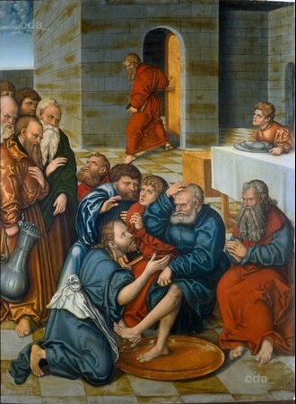
Helping in Worship
Preacher | Rev. James Heckman
Organist/Choir Director | Carolyn Williams
Acolyte
Altar | Barb Naska and Linda Sauter
Lector | Ken Anderson
Greeter(s) | Miriam Anderson
Communion Usher | Miriam Anderson
Communion Assistants | Becky Praster and Bea Von Watzdorf
Administration & Technology | Ken Anderson
Custodian | Dianna Streletz

