Evangelical Lutheran Church of Durham
P.O. Box 100, Durham PA, 18039 610-346-8500
durhamlutheran.org

Rev. James Heckman, Bridge Pastor

August 20, 2023
Twelfth Sunday after Pentecost

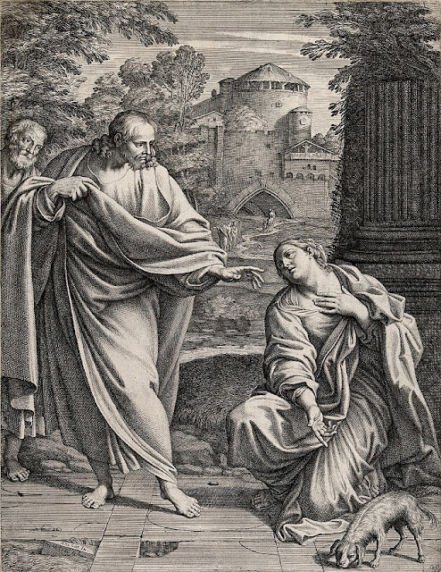

Samuel Wale
Introduction to Worship
In Isaiah we hear that God’s house shall be a house of prayer for all people and that God will gather the outcasts of Israel. The Canaanite woman in today’s gospel is a Gentile, an outsider, who is unflinching in her request that Jesus heal her daughter. As Jesus commends her bold faith, how might our church extend its mission to those on the margins of society? In our gathering around word and meal we receive strength to be signs of comfort, healing, and justice for those in need.

You can find the live stream at the following locations:
www.youtube.com/@DurhamLutheran

Worship from Sundays and Seasons.com. Copyright 2015 Augsburg Fortress. All rights reserved. Reprinted by permission under Augsburg Fortress Liturgies Annual License #SB170076.
Permission to podcast/stream the music in this service obtained from ONE LICENSE, License # 715933-A. All rights reserved.
Prelude:
Welcome
Confession and Forgiveness (Stand if you are able)
P: Blessed be the holy Trinity, ☩ one God, who greets us in this and every season, whose word never fails, whose promise is sure.
C: Amen.
P: Let us confess our sin in the presence of God and of our neighbors. (Silence for reflection) Merciful God,
C: we confess that we have sinned. We have hurt our community. We have squandered your blessings. We have hoarded your bounty. In the name of Jesus, forgive us and grant us your mercy.
P: Righteous God,
C: we confess that we have sinned. We have failed to be honest. We have lacked the courage to speak. We have spoken falsely. In the name of Jesus, forgive us and grant us your mercy.
P: God is a cup of cold water when we thirst. God offers boundless grace when we fail. Claim the gift of God’s mercy: you are freed and forgiven in the name of ☩ Jesus Christ.
C: Amen.

Opening Hymn - ELW 883 Vs. 1-4
Apostolic Greeting
P: The grace of our Lord Jesus Christ, the love of God, and the communion of the Holy Spirit be with you all.
C: And also with you.

Kyrie

Prayer of the Day
L: The Lord be with you. C: And also with you.
L: God of all peoples, your arms reach out to embrace all those who call upon you. Teach us as disciples of your Son to love the world with compassion and constancy, that your name may be known throughout the earth, through Jesus Christ, our Savior and Lord.
C: Amen.

(Please be Seated)
First Reading – Isaiah 56:1, 6-8
The prophet calls upon Israel to do justice in view of God’s imminent intervention to save. Righteousness and obedience define who belongs to the Israelite community—not race, nationality, or any other category.
L: A reading from Isaiah, the fifty-sixth chapter.
¹Thus says the Lord: Maintain justice, and do what is right, for soon my salvation will come, and my deliverance be revealed. ⁶And the foreigners who join themselves to the Lord, to minister to him, to love the name of the Lord, and to be his servants, all who keep the sabbath, and do not profane it, and hold fast my covenant— ⁷these I will bring to my holy mountain, and make them joyful in my house of prayer; their burnt offerings and their sacrifices will be accepted on my altar; for my house shall be called a house of prayer for all peoples.
⁸Thus says the Lord God, who gathers the outcasts of Israel, I will gather others to them besides those already gathered.
L: The Word of the Lord. C: THANKS BE TO GOD.

PSALM: Psalm 67

Let all the peoples praise you, O God.

L: ¹May God be merciful to us and bless us; may the light of God’s face shine upon us.

²Let your way be known upon earth, your saving health among all nations.

L: ³Let the peoples praise you, O God; let all the peoples praise you.

C: ⁴Let the nations be glad and sing for joy, for you judge the peoples with equity and guide all the nations on earth.

L: ⁵Let the peoples praise you, O God; let all the peoples praise you.

C: ⁶The earth has brought forth its increase; God, our own God, has blessed us.

L: ⁷May God give us blessing, and may all the ends of the earth stand in awe.

Second Reading: Romans 11:1-2a, 29-32
God has not rejected Israel. Rather, the call and gifts of God are irrevocable so that, while all have been disobedient, God has mercy upon all.
A reading from Romans, the eleventh chapter:
[Paul writes:] ¹I ask, then, has God rejected his people? By no means! I myself am an Israelite, a descendant of Abraham, a member of the tribe of Benjamin. ^{2a}God has not rejected his people whom he foreknew.
²⁹For the gifts and the calling of God are irrevocable. ³⁰Just as you were once disobedient to God but have now received mercy because of their disobedience, ³¹so they have now been disobedient in order that, by the mercy shown to you, they too may now receive mercy. ³²For God has imprisoned all in disobedience so that he may be merciful to all.
L: The Word of the Lord. C: THANKS BE TO GOD.
Gospel Acclamation (Please stand if you are able)

The Gospel – Matthew 15:[10-20] 21-28
Jesus teaches his disciples that true purity is a matter of the heart rather than outward religious observances. Almost immediately, this teaching is tested when a woman considered to be a religious outsider approaches him for help.
P: The Gospel according to Matthew. C: Glory to you, O Lord
[¹⁰[Jesus] called the crowd to him and said to them, “Listen and understand:¹¹it is not what goes into the mouth that defiles a person, but it is what comes out of the mouth that defiles.” ¹²Then the disciples approached and said to him, “Do you know that the Pharisees took offense when they heard what you said?” ¹³He answered, “Every plant that my heavenly Father has not planted will be uprooted. ¹⁴Let them alone; they are blind guides of the blind. And if one blind person guides another, both will fall into a pit.” ¹⁵But Peter said to him, “Explain this parable to us.” ¹⁶Then he said, “Are you also still without understanding? ¹⁷Do you not see that whatever goes into the mouth enters the stomach, and goes out into the sewer? ¹⁸But what comes out of the mouth proceeds from the heart, and this is what defiles. ¹⁹For out of the heart come evil intentions, murder, adultery, fornication, theft, false witness, slander. ²⁰These are what defile a person, but to eat with unwashed hands does not defile.”]
²¹Jesus left that place and went away to the district of Tyre and Sidon. ²²Just then a Canaanite woman from that region came out and started shouting, “Have mercy on me, Lord, Son of David; my daughter is tormented by a demon.” ²³But he did not answer her at all. And his disciples came and urged him, saying, “Send her away, for she keeps shouting after us.” ²⁴He answered, “I was sent only to the lost sheep of the house of Israel.” ²⁵But she came and knelt before him, saying, “Lord, help me.” ²⁶He answered, “It is not fair to take the children’s food and throw it to the dogs.” ²⁷She said, “Yes, Lord, yet even the dogs eat the crumbs that fall from their masters’ table.” ²⁸Then Jesus answered her, “Woman, great is your faith! Let it be done for you as you wish.” And her daughter was healed instantly.
P: This is the Gospel of the Lord.
C: Praise to you. O Christ.
Children’s Sermon / Sermon (please be seated)
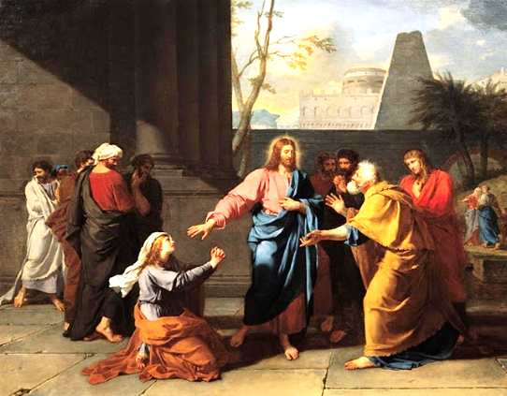
Jean Germain Drouais
Hymn of the Day: ELW 759

The Apostle’s Creed:
P: Living together in trust and hope, we confess our faith.
C: I believe in God, the Father almighty, creator of heaven and earth.
I believe in Jesus Christ, his only Son, our Lord. He was conceived by the power of the Holy Spirit and born of the virgin Mary. He suffered under Pontius Pilate, was crucified, died, and was buried. He descended into hell. On the third day he rose again. He ascended into heaven, and is seated at the right hand of the Father. He will come again to judge the living and the dead.
I believe in the Holy Spirit, the holy catholic Church, the communion of saints, the forgiveness of sins, the resurrection of the body, and the life everlasting. Amen.
PRAYERS OF INTERCESSION
P: Confident that God receives our joys and concerns, let us offer our prayers for the church, those in need, and all of creation.
A brief silence.
P: O God, your Spirit gathers the church. Shepherd those who are newly baptized and newly ordained in the proclamation of the gospel, breathe life into ecumenical and inter-religious endeavors, and support missionaries throughout the globe. Hear us, O God.
C: Your mercy is great.
P: You created the earth and all its inhabitants and declared it good. Clean polluted skies, seas, and soil, provide nourishment to plants and animals, and make us aware of our impact on the environment. Hear us, O God.
C: Your mercy is great.
P: You call leaders to bridge differences and practice generosity. Inspire all in authority to protect people in harm’s way, deliver those in bondage, support fair elections, provide care for military personnel and veterans, and show mercy to those for whom they have responsibility. Hear us, O God.
C: Your mercy is great.
P: You provide for those who suffer in body, mind, or spirit. Embrace people who have been rejected because of difference, heal trauma caused by racism or prejudice, shield any who are persecuted, console the dying, and heal the sick (especially). Hear us, O God.
C: Your mercy is great.
P: O God, you journey with us in all of life’s transitions. Guide those preparing for baptism, marriage, and retirement. Guide our church council and committees in their visioning and ministry (especially name/s of specific ministries). Safeguard those who travel. Hear us, O God.
C: Your mercy is great.
Here other intercessions may be offered.
P: We give you thanks for those who now rest from their labors. Motivate us by their lives of dedication to the gospel, until that day when we join with them in our eternal home. Hear us, O God.
C: Your mercy is great.
P: Into your hands, O God, we commend all for whom we pray, in the name of the one who reconciled all creation to himself, Jesus Christ our Savior.
C: Amen.
Sharing of the Peace
P: The peace of Christ be with you always.
C: And also with you.
P: Sisters and brothers, rejoice. Mend your ways, encourage one another, agree with one another, live in peace. The peace of the Lord be with you always.
C: And also with you.
OFFERING
Choir Anthem: When the Poor Ones

PRESENTATION OF THE GIFTS
P: God of field and forest, sea and sky, you are the giver of all good things. Sustain us with these gifts of your creation, and multiply your graciousness in us, that the world may be fed with your love, through Jesus Christ, our Savior and Lord.
C: Amen.

THE HOLY COMMUNION
The Great Thanksgiving
P: The Lord be with you.
C: And also with you.
P: Lift up your hearts.
C: We lift them to the Lord.
P: Let us give thanks to the Lord our God.
C: It is right to give our thanks and praise.
Preface
It is indeed right, our duty and our joy, that we should at all times and in all places give thanks and praise to you, almighty and merciful God. You reveal your glory as the glory of the Father, the Son, and the Holy Spirit: equal in majesty, undivided in splendor, one Lord, one God, ever to be adored in your eternal glory. And so, with all the choirs of angels, with the church on earth and the hosts of heaven, we praise your name and join their unending hymn:
Eucharistic Prayer (said by Pastor)
P: Let us pray with confidence in the words our Savior gave us:
C: Our Father, who art in heaven, hallowed be thy name, thy kingdom come, thy will be done, on earth as it is in heaven. Give us this day our daily bread; and forgive us our trespasses, as we forgive those who trespass against us; and lead us not into temptation, but deliver us from evil. For thine is the kingdom, and the power, and the glory, forever and ever. Amen.
Invitation to Communion
P: All people are called to Christ’s table. Come, eat what is good.
Distribution of Bread & Fruits of the Vine (please follow ushers)

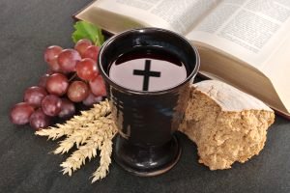

Hymn during Communion: ELW 612

Prayer after Communion
P: We thank you, generous God, for the refreshment we have received at your banquet table. Send us now to spread your generosity into all the world, through the one who is our dearest treasure, Jesus Christ, our Savior and Lord.
C: Amen.
Announcements
BLESSING
P: The God who calls across the cosmos and speaks in the smallest seed ☩ bless, keep, and sustain you now and to the end of the age. C: Amen.

SENDING SONG: ELW 650
DISMISSAL
P: Go in peace. Share the harvest.
C: Thanks be to God.
Postlude

ANNOUNCEMENTS
BAPTISMS, BIRTHDAYS & ANNIVERSARY
 |  | BIRTHDAYS | ANNIVERSARIES |  | BAPTISMS
23 |  |  |  | Peter Streletz
24 | Kendall Beerer

THIS WEEK’S ACTIVITIES
Sunday, August 20 | 9:30 AM  After Worship | Worship - Pr. Jim Heckman  Lemonade on the Lawn.
Monday, August 21 | 7:00 - 8:00 PM | Webinar: “Stewardship When Economics are Uncertain”  https://ministrylink.org/events/webinar-Stewardship-when-economics-are-uncertain
Wednesday, August 23 | 10:00 AM-1:00 PM | Office hours
Thursday, August 24 | 12:00 PM-3:00 PM  12:30 PM | Office hours  Chat & Chew with Pr. Jim
UPCOMING ACTIVITIES
Sunday, August 27 | 9:30 AM  After Worship | Worship - Pr. Jim Heckman  Lemonade on the Lawn.  Music & Worship Meeting
Wednesday, August 30 | 10:00 AM-1:00 PM | Office hours
Thursday, August 31 | 12:00 PM-3:00 PM  12:30 PM | Office hours  Chat & Chew with Pr. Jim
Sunday, September 3 | 9:30 AM  After Worship | Worship - Pr. Jim Heckman  Lemonade on the Lawn.
Wednesday, September 6 | 10:00 AM-1:00 PM | Office hours
Thursday, September 7 | 12:00 PM-3:00 PM  12:30 PM | Office hours  Chat & Chew with Pr. Jim
Winter Coat Project
We are participating in the Winter Coat Project sponsored by Christian Aid Ministries (CAM) this year. They are collecting new or slightly used winter coats to ship to Syria, Yemen, or Ukraine. If you would like to donate coat(s) please get them to the church by August 27. It costs about $2.50 to ship each coat. If you would rather donate money for coats or shipping, please mark your donation envelope with your name, envelope number, amount, and "Winter Coats." For more information see Helen Dungan.
July Outreach - Our Outreach envelopes for August have been designated for local Food banks. You can sign up on the bulletin board in the narthex to donate a food basket. You can either buy the supplies or Helen Dungan can shop for you.
Care-A-Lot has a wish list available on the wall in the Narthex, If you would like to donate an item for the upcoming school year, please select one or more item(s) from this list.
For Healing of those in our Congregation:
Barbara Altemus; Michael Altemus; Joanne & David Antoni; Brian Ashmore; Esther Crouse; Helen Dungan; Frank Erceg; Kenneth Hager; George Kreitz; Frank Mammana; Paul McGinn; Cheryl Mesko; Barbara Naska; Ben Naska Sr.; Wes Simmons; Ed Xander; Joanne and Bobby Ziegenfuss.
For Healing of Friends and Family:
Lynn Bailey; Ron & Kathy Ballek; Anthony Beck; Jason Bigley; Sherri Breithoff; Melissa Carafa; Deb Carmichael; Stephanie Courtney; Nancy Davis; Rev. Dennis Durasoff; Nancy Edelen; Diane Ellington; Cindy Gilligan; Fred Foerster; Gerry Foran; Debbie Gardner; Candie Gimbar; Josephine Gimelson & family; Baree Lee Goodman; Penni Griffith; Ashton Hales; Bill Hunt; Lois James & family; Martine King; Jim McAnally; Letitia McCrea; Sue Odor; Lucia Otero; Jennifer Phelps; Jean Pratt; Connie Rugen; Linda Saunders; Paul Sauter; Debbie Schultz; David Sebring; Alex Sempt; Shawn Stadt; Pat Stangil; Kay Stokes; Donna Storm; Russ Trauger; Kelly Walsh; Henry Wong and Scotty Yurconis.
For those who are Homebound:
Cleo & Ken Eck; Norma Fox; Betty Kreitz; Phyllis Lanshe; Jayne Miller; Silas Rodenbach and Hal Taylor.
For families and friends grieving the loss of:
Stan Aagaard; Michael Barats; Joann Gary; Lani Schlegel; Don Seipt; Marilyn Seipt; Hal Taylor; Ann Valent
If you want to add or remove someone from the prayer list, please contact Joan Mammana either by phone (610-258-5717 or 610-417-6553) or by email at: PrayerChain@durhamlutheran.org
Helping in Worship
Preacher | Rev. James Heckman
Organist /Choir Director | Carolyn Williams
Greeter(s) | Helen Dungan
Altar | Barb Naska & Dot Peterman
Acolyte | TBD
Lector | Mark Harwick
Head / Communion Usher | Mark Harwick
Lemonade on the Lawn | Helen Dungan
Council Counting Team | Mark Harwick & Cathy Muller
Administration & Technology | Ken Anderson
Custodian | Dianna Streletz

