Evangelical Lutheran Church of Durham
P.O. Box 100, Durham PA, 18039 610-346-8500
durhamlutheran.org
Rev. James Heckman, Bridge Pastor

December 17, 2023
Third Sunday of Advent

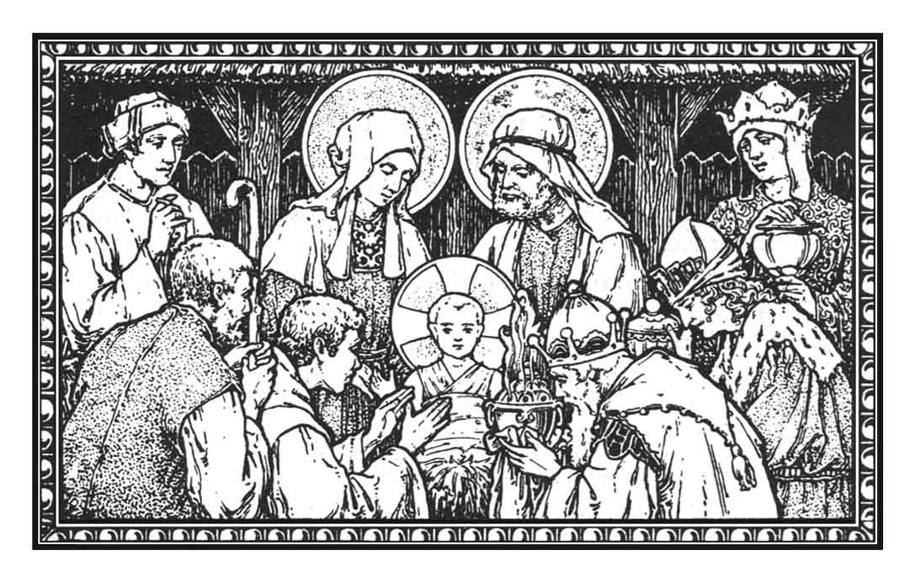

Shut-in Christmas Holiday Service

(Please remain seated throughout the service)

You can find the live stream at the following locations:
www.youtube.com/@DurhamLutheran

Worship from Sundays and Seasons.com. Copyright 2015 Augsburg Fortress. All rights reserved. Reprinted by permission under Augsburg Fortress Liturgies Annual License #SB170076.
Permission to podcast/stream the music in this service obtained from ONE LICENSE, License # 715933-A. All rights reserved.
Prelude:
Welcome
P: As we gather, we hear again the good news the angels proclaimed: God has come for all people through the birth of the one named Jesus. Through Bethlehem’s manger God comes into the chaos, messiness, and vulnerability of the world. In all things and at all times, we rejoice that God comes to save us and reigns in love. We come to adore Jesus who is Savior, Christ, and Lord.

Confession and Forgiveness
P: Amid the troubles and fears of this world, let us confess our sin and welcome God’s forgiveness, grace, and love.
Silence is kept for reflection.
P: Mary accepted your call to be the mother of Jesus.
C: Forgive our lack of faith and trust.
P: Your Son was born in the poverty of a stable.
C: Forgive our neglect of the poor.
P: The shepherds left their flocks and went to Bethlehem.
C: Forgive our selfishness and complacency.
P: With great joy the angels proclaimed, “Do not fear. For I bring you good news of great joy. Today is born a Savior, who is Christ the Lord.”
In ☩ Jesus, who is Savior, Christ, and Lord, our sins are forgiven. May you know the peace which the angels sang from the heavens. Indeed, God’s forgiveness is good news of great joy!
C: Amen.
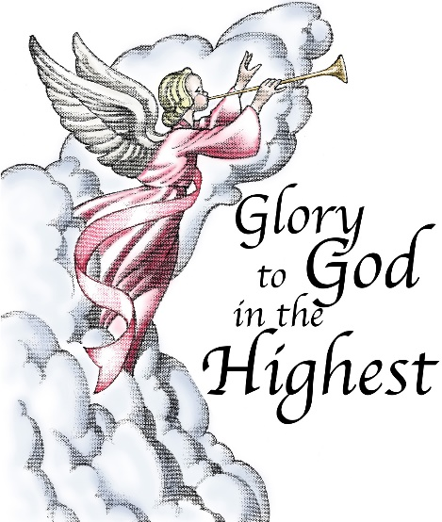

Gathering Song
ELW 289
Dialogue
P: Jesus, the bright Morning Star, shines light in the world.
C: By day and night he shines for all to see.
P: Jesus was born in the midst of injustice and poverty
C: that the world may see the justice and richness of God.
P: God so loved the world that God sent Jesus,
C: so that all who believe in him may not perish but have eternal life.
P: Jesus is the light of the world.
C: Jesus is the light of our lives.
P: Sing to God a new song!
C: A song of hope, joy, and peace around the world.
Opening Prayer
P: The Lord be with you.
C: And also with you.
P: Let us pray. Gracious God of heaven and earth, you have thrown a lifeline to us in our darkness—a beam of light that shines through Jesus. Though born in a manger, he is the firstborn of all creation. Though crucified on a cross, he is the Lord of life. Fill us with the wonder and joy of his presence in the world and in our hearts.
C: Amen.
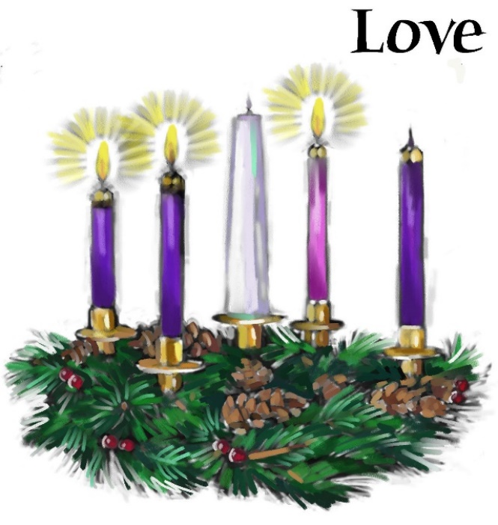
Lessons and Carols
First Reading: Genesis 1:1-5, 14-18
1 When God began to create^{[a]} the heavens and the earth, ² the earth was complete chaos, and darkness covered the face of the deep, while a wind from God^{[b]} swept over the face of the waters. ³ Then God said, “Let there be light,” and there was light. ⁴ And God saw that the light was good, and God separated the light from the darkness. ⁵ God called the light Day, and the darkness he called Night. And there was evening and there was morning, the first day.

¹⁴ And God said, “Let there be lights in the dome of the sky to separate the day from the night, and let them be for signs and for seasons and for days and years, ¹⁵ and let them be lights in the dome of the sky to give light upon the earth.” And it was so. ¹⁶ God made the two great lights—the greater light to rule the day and the lesser light to rule the night—and the stars. ¹⁷ God set them in the dome of the sky to give light upon the earth, ¹⁸ to rule over the day and over the night, and to separate the light from the darkness. And God saw that it was good.

ELW 282
Second Reading: Micah 5:2-5a
^{[a]}But you, O Bethlehem of Ephrathah,
who are one of the little clans of Judah,
from you shall come forth for me
one who is to rule in Israel,
whose origin is from of old,
from ancient days.
³ Therefore he shall give them up until the time
when she who is in labor has brought forth;
then the rest of his kindred shall return
to the people of Israel.
⁴ And he shall stand and feed his flock in the strength of the Lord,
in the majesty of the name of the Lord his God.
And they shall live secure, for now he shall be great
to the ends of the earth,
⁵ and he shall be the one of peace.

ELW 279
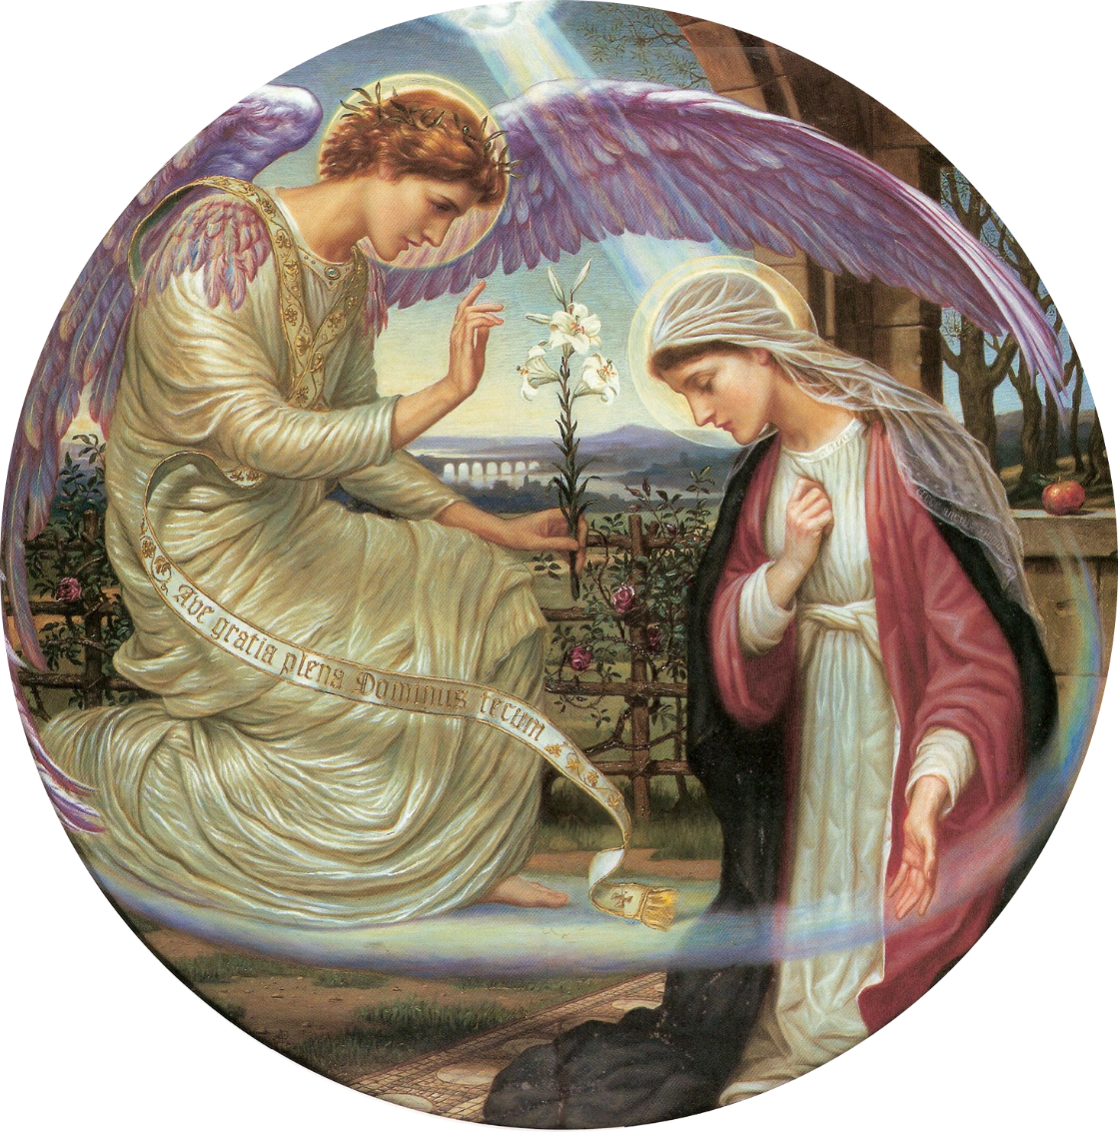
Third Reading: Luke 1:26-35, 38
²⁶ In the sixth month the angel Gabriel was sent by God to a town in Galilee called Nazareth, ²⁷ to a virgin engaged to a man whose name was Joseph, of the house of David. The virgin’s name was Mary. ²⁸ And he came to her and said, “Greetings, favored one! The Lord is with you.”^{[a]} ²⁹ But she was much perplexed by his words and pondered what sort of greeting this might be. ³⁰ The angel said to her, “Do not be afraid, Mary, for you have found favor with God. ³¹ And now, you will conceive in your womb and bear a son, and you will name him Jesus. ³² He will be great and will be called the Son of the Most High, and the Lord God will give to him the throne of his ancestor David. ³³ He will reign over the house of Jacob forever, and of his kingdom there will be no end.” ³⁴ Mary said to the angel, “How can this be, since I am a virgin?”^{[b]} ³⁵ The angel said to her, “The Holy Spirit will come upon you, and the power of the Most High will overshadow you; therefore the child to be born^{[c]} will be holy; he will be called Son of God.
³⁸ Then Mary said, “Here am I, the servant of the Lord; let it be with me according to your word.” Then the angel departed from her.

ELW 257
Fourth Reading: Matthew 1:18-25
¹⁸ Now the birth of Jesus the Messiah^{[a]} took place in this way. When his mother Mary had been engaged to Joseph, but before they lived together, she was found to be pregnant from the Holy Spirit. ¹⁹ Her husband Joseph, being a righteous man and unwilling to expose her to public disgrace, planned to divorce her quietly. ²⁰ But just when he had resolved to do this, an angel of the Lord appeared to him in a dream and said, “Joseph, son of David, do not be afraid to take Mary as your wife, for the child conceived in her is from the Holy Spirit. ²¹ She will bear a son, and you are to name him Jesus, for he will save his people from their sins.” ²² All this took place to fulfill what had been spoken by the Lord through the prophet:
²³ “Look, the virgin shall become pregnant and give birth to a son,
and they shall name him Emmanuel,”
which means, “God is with us.” ²⁴ When Joseph awoke from sleep, he did as the angel of the Lord commanded him; he took her as his wife ²⁵ but had no marital relations with her until she had given birth to a son,^{[b]} and he named him Jesus.
ELW 254

Fifth Reading: Luke 2:8-20
⁸ Now in that same region there were shepherds living in the fields, keeping watch over their flock by night. ⁹ Then an angel of the Lord stood before them, and the glory of the Lord shone around them, and they were terrified. ¹⁰ But the angel said to them, “Do not be afraid, for see, I am bringing you good news of great joy for all the people: ¹¹ to you is born this day in the city of David a Savior, who is the Messiah,^{[a]} the Lord. ¹² This will be a sign for you: you will find a child wrapped in bands of cloth and lying in a manger.” ¹³ And suddenly there was with the angel a multitude of the heavenly host,^{[b]} praising God and saying,
¹⁴ “Glory to God in the highest heaven,
and on earth peace among those whom he favors!”^{[c]}
¹⁵ When the angels had left them and gone into heaven, the shepherds said to one another, “Let us go now to Bethlehem and see this thing that has taken place, which the Lord has made known to us.” ¹⁶ So they went with haste and found Mary and Joseph and the child lying in the manger. ¹⁷ When they saw this, they made known what had been told them about this child, ¹⁸ and all who heard it were amazed at what the shepherds told them, ¹⁹ and Mary treasured all these words and pondered them in her heart. ²⁰ The shepherds returned, glorifying and praising God for all they had heard and seen, just as it had been told them.
ELW 275

Sixth Reading: Matthew 1:18-25
¹⁸ Now the birth of Jesus Christ^{[a]} took place in this way. When his mother Mary had been betrothed to Joseph, before they came together she was found to be with child of the Holy Spirit; ¹⁹ and her husband Joseph, being a just man and unwilling to put her to shame, resolved to divorce her quietly. ²⁰ But as he considered this, behold, an angel of the Lord appeared to him in a dream, saying, “Joseph, son of David, do not fear to take Mary your wife, for that which is conceived in her is of the Holy Spirit; ²¹ she will bear a son, and you shall call his name Jesus, for he will save his people from their sins.” ²² All this took place to fulfil what the Lord had spoken by the prophet:
²³ “Behold, a virgin shall conceive and bear a son,
and his name shall be called Emman′u-el”
(which means, God with us). ²⁴ When Joseph woke from sleep, he did as the angel of the Lord commanded him; he took his wife, ²⁵ but knew her not until she had borne a son; and he called his name Jesus.
WOV 642 - I wonder as I wander
1 I wonder as I wander, out under the sky,
how Jesus the Savior did come for to die
for poor ordinary people like you and like I;
I wonder as I wander, out under the sky.
2 When Mary birthed Jesus, 'twas in a cow's stall
with wise men and farmers and shepherd and all.
but high from God's heaven a star's light did fall,
and the promise of ages it did then recall.
3 If Jesus had wanted for any wee thing,
a star in the sky, or a bird on the wing,
or all of God's angels in heaven for to sing,
he surely could have it, 'cause he was the King.
4 I wonder as I wander, out under the sky,
how Jesus the Savior did come for to die
for poor ordinary people like you and like I;
I wonder as I wander, out under the sky.
Seventh Reading: John 1:1-14
1 In the beginning was the Word, and the Word was with God, and the Word was God. ² He was in the beginning with God. ³ All things came into being through him, and without him not one thing came into being. What has come into being ⁴ in him was life,^{[a]} and the life was the light of all people. ⁵ The light shines in the darkness, and the darkness did not overtake it.
⁶ There was a man sent from God whose name was John. ⁷ He came as a witness to testify to the light, so that all might believe through him. ⁸ He himself was not the light, but he came to testify to the light. ⁹ The true light, which enlightens everyone, was coming into the world.^{[b]}
¹⁰ He was in the world, and the world came into being through him, yet the world did not know him. ¹¹ He came to what was his own,^{[c]} and his own people did not accept him. ¹² But to all who received him, who believed in his name, he gave power to become children of God, ¹³ who were born, not of blood or of the will of the flesh or of the will of man, but of God.
¹⁴ And the Word became flesh and lived among us, and we have seen his glory, the glory as of a father’s only son,^{[d]} full of grace and truth.
ELW 270

Homily

Responsive Prayer
P: It is you, loving God, who lights our path with truth.
C: Your Word, Jesus, is truth.
P: In his light, draw all to the manger
C: to gather in wonder with the shepherds.
P: In his light, draw all to the manger
C: to kneel in reverence with the wise ones.
P: In his light, draw all to the manger
C: to sing for joy with the angels.
P: In the brightness of his life
C: cast away the darkness of injustice, poverty, and hunger in the world.
P: It is you, loving God, who meets us on our way.
C: In the light of Jesus, show the world the way of life. Amen.
OFFERING
Choir Anthem: Come, My Light – Anne Krentz Organ
Presentation of the Gifts

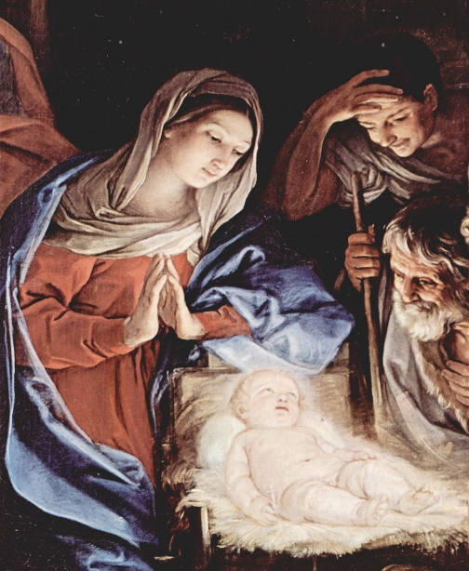

Offertory Carol - ELW 296
THE HOLY COMMUNION
The Great Thanksgiving
P: The Lord be with you.
C: And also with you.
P: Lift up your hearts.
C: We lift them to the Lord.
P: Let us give thanks to the Lord our God.
C: It is right to give our thanks and praise.
Words of Institution

Lord’s Prayer
P: Let us pray with confidence in the words our Savior gave us:
C: Our Father, who art in heaven, hallowed be thy name, thy kingdom come, thy will be done, on earth as it is in heaven. Give us this day our daily bread; and forgive us our trespasses, as we forgive those who trespass against us; and lead us not into temptation, but deliver us from evil. For thine is the kingdom, and the power, and the glory, forever and ever. Amen.
Invitation to Communion
P: In this meal, righteousness and peace meet together. Come, take your place at the table.
Distribution (Communion will be served in the pew to any who desire it.)
Communion Carol – ELW 292

Prayer after Communion
P: God our redeemer, you have fed us at this table with gifts of grace, truth, and life. As you have gathered us in joy, send us forth as messengers of your peace. Make us shine with the good news of your glory, born to us in Jesus Christ, our Savior and Lord.
C: Amen.
BLESSING
P: The God of peace bless you, the love of Christ sustain you in hope, and the anointing of the Spirit ☩ remain upon you now and forever.
.C: Amen.
P: Praise God, from whom all blessings flow!
C: Praise God, all creatures here below!
P: You are the shepherds telling the story.
C: We tell it in the streets and across the land.
P: You are the wise ones worshiping with thanksgiving.
C: We worship with gifts of song and service, talents and treasures.
P: You are the angels announcing peace.
C: We live with joy and go now in peace.
P: Almighty God, Father, ☩ Son, and Holy Spirit, bless you now and forever.
C: Amen.

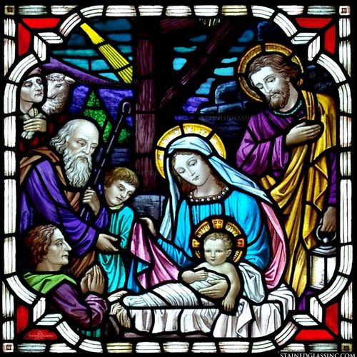

Sending Song - ELW 267
DISMISSAL
P: Christ the Savior is born! Go in peace. Proclaim this good news.
C: Thanks be to God.

