Evangelical Lutheran Church of Durham
P.O. Box 100, Durham PA, 18039 610-346-8500
durhamlutheran.org
Rev. James Heckman, Pastor
Cell: 267-664-3160

February 18, 2024

First Sunday in Lent

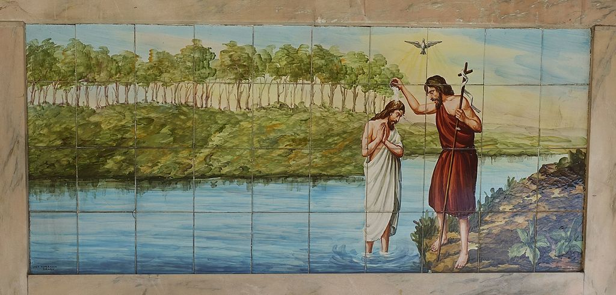
By Joseolgon

Introduction to Worship
On Ash Wednesday the church began its journey toward baptismal immersion in the death and resurrection of Christ. This year, the Sundays in Lent lead us to focus on five covenants God makes in the Hebrew Scriptures and to use them as lenses through which to view baptism. First Peter connects the way God saved Noah’s family in the flood with the way God saves us through the water of baptism. The baptismal covenant is made with us individually, but the new life we are given in baptism is for the sake of the whole world.

You can find the live stream at the following locations:
www.youtube.com/@DurhamLutheran
Worship from Sundays and Seasons.com. Copyright 2015 Augsburg Fortress. All rights reserved. Reprinted by permission under Augsburg Fortress Liturgies Annual License #SB170076.
Permission to podcast/stream the music in this service obtained from ONE LICENSE, License # 715933-A. All rights reserved.
Prelude: Larghetto - Jean Maria LeClair
GATHERING
P: The Holy Spirit calls us together as the people of God.
CONFESSION AND FORGIVENESS (Stand if you are able)
All may make the sign of the cross, the sign that is marked at baptism, as the presiding minister begins.
P: Blessed be the holy Trinity, ☩ one God, who writes the law on our hearts, who draws all people together through Jesus.
C: Amen.
P: Held in God’s mercy, let us confess our sin in the presence of God and of one another.
Silence is kept for reflection.
P: Holy God,
C: we confess that we are caught in snares of sin and cannot break free. We hoard resources while our neighbors are hungry and cold. We speak in ways that silence others. We are silent when we should speak up. We keep score in our hearts. We let hurts grow into hatred. For all these things and for sins only you know, forgive us, Lord. Amen.
P: Here is a flood of grace: Out of love for the whole world, God draws near to us, breaks every snare of sin, washes away our wrongs, and restores the promise of life through ☩ Jesus Christ.
C: Amen.

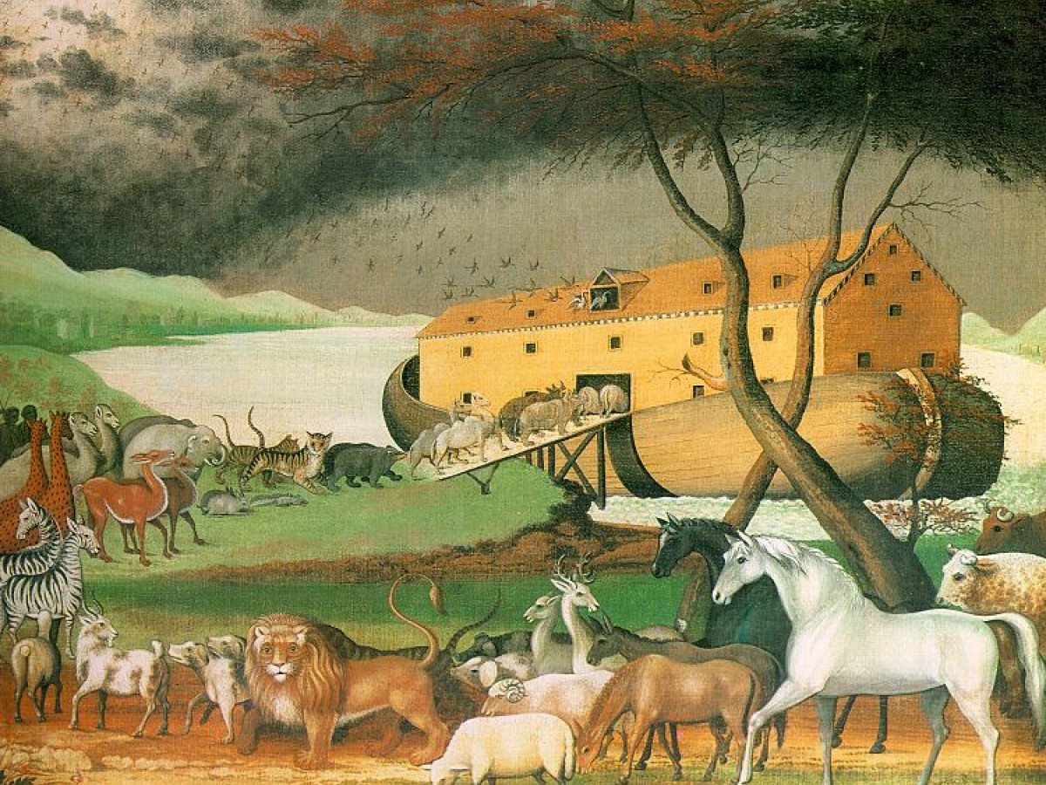

Entrance Hymn: ELW 322
Prayer of the Day
L: The Lord be with you.
C: And also with you.
L: Holy God, heavenly Father, in the waters of the flood you saved the chosen, and in the wilderness of temptation you protected your Son from sin. Renew us in the gift of baptism. May your holy angels be with us, that the wicked foe may have no power over us, through Jesus Christ, our Savior and Lord, who lives and reigns with you and the Holy Spirit, one God, now and forever.
C: Amen.
(Please be Seated)
First Reading – 9:8-17
Today’s reading is the conclusion to the flood story. Because of human sin, God destroys the earth by flood, saving only Noah, his family, and the animals on the ark. Yet divine destruction gives way to divine commitment. As in the first creation, God blesses humanity and establishes a covenant with all creatures.
L: A reading from the ninth chapter of Genesis:
⁸God said to Noah and to his sons with him, ⁹“As for me, I am establishing my covenant with you and your descendants after you, ¹⁰and with every living creature that is with you, the birds, the domestic animals, and every animal of the earth with you, as many as came out of the ark. ¹¹I establish my covenant with you, that never again shall all flesh be cut off by the waters of a flood, and never again shall there be a flood to destroy the earth.” ¹²God said, “This is the sign of the covenant that I make between me and you and every living creature that is with you, for all future generations: ¹³I have set my bow in the clouds, and it shall be a sign of the covenant between me and the earth. ¹⁴When I bring clouds over the earth and the bow is seen in the clouds, ¹⁵I will remember my covenant that is between me and you and every living creature of all flesh; and the waters shall never again become a flood to destroy all flesh. ¹⁶When the bow is in the clouds, I will see it and remember the everlasting covenant between God and every living creature of all flesh that is on the earth.” ¹⁷God said to Noah, “This is the sign of the covenant that I have established between me and all flesh that is on the earth.”
L: The Word of the Lord.
C: Thanks be to God.
Psalm: Psalm 25:1-10
L: ¹To you, O LORD, I lift up my soul
C: ²O my God, in you I trust; do not let me be put to shame; do not let my enemies exult over me
L: ³Do not let those who wait for you be put to shame; let them be ashamed who are wantonly treacherous
C: ⁴Make me to know your ways, O LORD; teach me your paths
L: ⁵Lead me in your truth, and teach me, for you are the God of my salvation; for you I wait all day long
C: ⁶Be mindful of your mercy, O LORD, and of your steadfast love, for they have been from of old
L: ⁷Do not remember the sins of my youth or my transgressions; according to your steadfast love remember me, for your goodness' sake, O LORD!
C: ⁸Good and upright is the LORD; therefore he instructs sinners in the way
L: ⁹He leads the humble in what is right, and teaches the humble his way
C: ¹⁰All the paths of the LORD are steadfast love and faithfulness, for those who keep his covenant and his decrees.
Second Reading: 1 Peter 3:18-22
As God acted through Christ’s suffering and death to bring us to God, so God acts through baptism to save us from a sinful existence. This spiritual cleansing marks our new life in Christ.
A reading from the third chapter of 1 Peter:
¹⁸Christ also suffered for sins once for all, the righteous for the unrighteous, in order to bring you to God. He was put to death in the flesh, but made alive in the spirit, ¹⁹in which also he went and made a proclamation to the spirits in prison, ²⁰who in former times did not obey, when God waited patiently in the days of Noah, during the building of the ark, in which a few, that is, eight persons, were saved through water. ²¹And baptism, which this prefigured, now saves you—not as a removal of dirt from the body, but as an appeal to God for a good conscience, through the resurrection of Jesus Christ, ²²who has gone into heaven and is at the right hand of God, with angels, authorities, and powers made subject to him.
L: The Word of the Lord.
C: THANKS BE TO GOD.
Gospel Acclamation (Please stand if you are able)
The Gospel – Mark 1:9-15
The Spirit that comes upon Jesus at his baptism sustains him when he is tested by Satan so that he might proclaim the good news of God’s reign.
P: The Holy Gospel according to Matthew the sixth chapter.
C: Glory to you, O Lord
⁹In those days Jesus came from Nazareth of Galilee and was baptized by John in the Jordan. ¹⁰And just as he was coming up out of the water, he saw the heavens torn apart and the Spirit descending like a dove on him. ¹¹And a voice came from heaven, “You are my Son, the Beloved; with you I am well pleased.”
¹²And the Spirit immediately drove him out into the wilderness. ¹³He was in the wilderness forty days, tempted by Satan; and he was with the wild beasts; and the angels waited on him.
¹⁴Now after John was arrested, Jesus came to Galilee, proclaiming the good news of God, ¹⁵and saying, “The time is fulfilled, and the kingdom of God has come near; repent, and believe in the good news.”
P: The Gospel of the Lord.
C: Praise to you. O Christ.
Children’s Sermon / Sermon (please be seated)
Hymn of the Day: ELW 517
Apostles’ Creed
P: With the whole church, let us confess our faith.
C: I believe in God, the Father almighty, creator of heaven and earth.
I believe in Jesus Christ, God’s only Son, our Lord,
who was conceived by the Holy Spirit, born of the virgin Mary,
suffered under Pontius Pilate, was crucified, died, and was buried;
he descended to the dead. On the third day he rose again;
he ascended into heaven, he is seated at the right hand of the Father,
and he will come to judge the living and the dead.
I believe in the Holy Spirit, the holy catholic church, the communion of saints,
the forgiveness of sins, the resurrection of the body, and the life everlasting. Amen.

PRAYERS OF INTERCESSION
P: Trusting in God’s promise to reconcile all things, let us pray for the church, the well-being of creation, and a world in need.
A brief silence.
P: God our truth, the ark of your church has room for many expressions of faith. We give thanks for voices that challenge and awaken your people. Hear us, O God.
C: Your mercy is great.
P: God our maker, you remember your covenant with the earth and its inhabitants. Rescue communities and creatures hurting from natural disasters. Preserve species and habitats endangered by human carelessness and disregard. Hear us, O God.
C: Your mercy is great.
P: God our light, you know our weakness. Free all who govern from the temptations of power. Sustain all who work for human rights in every nation. Hear us, O God.
C: Your mercy is great.
P: God our help, you care for your beloved children. Comfort all who are grieving, ill, afraid, in pain, or in despair. Feed hungry people living in food deserts. Protect any at risk from exploitation and abuse. Hear us, O God.
Your mercy is great.
C: Your mercy is great.
P: God our home, you gather your people. Grant us health and safety as we assemble. Keep us mindful of any who are homebound, hospitalized, convalescing, or traveling (especially). Hear us, O God.
C: Your mercy is great.
Here other intercessions may be offered.
P: You redeem us from death, faithful God. We give thanks for those who served you in the church. Bring us with all the saints into everlasting joy. Hear us, O God.
C: Your mercy is great.
P: Accompany us on our journey, God of grace, and receive the prayers of our hearts, through Jesus Christ, our Savior.
C: Amen.
OFFERING
Choir Anthem: Lenten Prayer - Antonio Salieri
Presentation of the Gifts
Offering Prayer
P: Jesus, you are the bread of life and the host of this meal. Bless these gifts that we have gathered that all people may know your goodness. Feed us not only with this holy food but with hunger for justice and peace. We pray this in your name.
C: Amen.
THE HOLY COMMUNION
The Great Thanksgiving
P: The Lord be with you.
C: And also with you.
P: Lift up your hearts.
C: We lift them to the Lord.
P: Let us give thanks to the Lord our God.
C: It is right to give our thanks and praise.
Preface:
It is indeed right, our duty and our joy, that we should at all times and in all places give thanks and praise to you, almighty and merciful God, through our Savior Jesus Christ. You call your people to cleanse their hearts and prepare with joy for the paschal feast, that, renewed in the gift of baptism, we may come to the fullness of your grace. And so, with all the choirs of angels, with the church on earth and the hosts of heaven, we praise your name and join their unending hymn:

Eucharistic Prayer (said by Pastor)
You are indeed holy, almighty and merciful God. You are most holy, and great is the majesty of your glory.
You so loved the world that you gave your only Son, so that everyone who believes in him may not perish but have eternal life.
We give you thanks for his coming into the world to fulfill for us your holy will and to accomplish all things for our salvation.
In the night in which he was betrayed, our Lord Jesus took bread, and gave thanks; broke it, and gave it to his disciples, saying:
Take and eat; this is my body, given for you. Do this for the remembrance of me.
Again, after supper, he took the cup, gave thanks, and gave it for all to drink, saying:
This cup is the new covenant in my blood, shed for you and for all people for the forgiveness of sin. Do this for the remembrance of me.
For as often as we eat of this bread and drink from this cup, we proclaim the Lord’s death until he comes.
Remembering, therefore, his salutary command, his life-giving passion and death, his glorious resurrection and ascension, and the promise of his coming again, we give thanks to you, O Lord God Almighty, not as we ought but as we are able; we ask you mercifully to accept our praise and thanksgiving and with your Word and Holy Spirit to bless us, your servants, and these your own gifts of bread and wine, so that we and all who share in the body and blood of Christ may be filled with heavenly blessing and grace, and, receiving the forgiveness of sin, may be formed to live as your holy people and be given our inheritance with all your saints.

To you, O God, Father, Son, and Holy Spirit, be all honor and glory in your holy church, now and forever.
P: Let us pray with confidence in the words our Savior gave us:
C: Our Father, who art in heaven, hallowed be thy name, thy kingdom come, thy will be done, on earth as it is in heaven. Give us this day our daily bread; and forgive us our trespasses, as we forgive those who trespass against us; and lead us not into temptation, but deliver us from evil. For thine is the kingdom, and the power, and the glory, forever and ever. Amen.
Invitation to Communion
P: Bread for the journey. A feast for hungry hearts. Come!
Distribution of Bread & Fruits of the Vine (please follow ushers)
Hymn during Communion: ELW 325

Prayer after Communion
P: Generous God, at this table we have tasted your immeasurable grace. As grains of wheat are gathered into one bread, now make us one loaf to feed the world; in the name of Jesus, the Bread of life.
C: Amen.
Announcements
BLESSING
P: Beloved, we are God’s own people, holy, washed, renewed. God bless you and keep you, shower you with mercy, fill you with courage, and ☩ give you peace.
C: Amen.
SENDING SONG: ELW 446
Dismissal
P: Go in peace. Share your bread.
C: Thanks be to God.
Postlude: Benediction - Archangelo Corelli
ANNOUNCEMENTS
 | BIRTHDAYS | ANNIVERSARIES | BAPTISMS
18 | Karen Bolesta
19 | Joanne Antoni
20 | Lee Ann Kressman | Linda & David Sauter (43)
21 | Ed Xander
22 |  | Diane & Steve DeWalt (41)
24 | Kris Simmons
THIS WEEK’S ACTIVITIES
Sunday, February 18  First Sunday in Lent | 10:00 AM  5:30 PM | Communion Worship  Confirmation Class @ Durham
Wednesday, February 21 | 10:00 AM - 2:00 PM  12:00 PM  6:00 PM  6:45 PM | Office Hours  Chat & Chew with Pr. Jim  PALM Midweek Gathering  Change of Season @ Evangelical, Durham  Soup Supper  Devotion
Thursday, February 22 | 10:00 AM - 11:00 PM  11:00 AM - 11:15 PM  11:00 AM - 1:00 PM  1:00 PM - 3:00 PM  7:00 PM | Choir rehearsal  Care -A-Lot Visit  Office hours  Adult Bible Study @ Hlavaty's  UB Conference Exec Comm.
UPCOMING ACTIVITIES
Sunday, February 25  Second Sunday in Lent | 10:00 AM  After Worship | Communion Worship  Annual Congregational Meeting  (Snow Date March 3)
Tuesday, February 27 | 7:00 pm | Care-a-Lot 40th Anniversary planning meeting
Wednesday, February 28 | 10:00 AM - 2:00 PM  11:00 AM - 11:15 PM  12:00 PM  6:00 PM  6:45 PM | Office Hours  Care -A-Lot Visit  Chat & Chew with Pr. Jim  PALM Midweek Gathering  Change of Habit @ St. Peter's, Riegelsville  Soup Supper  Devotion
Thursday, February 29 | 10:00 AM - 11:00 PM  11:00 AM - 1:00 PM  1:00 PM - 3:00 PM | Choir rehearsal  Office hours  Adult Bible Study @ Hlavaty's
Sunday, March 3  Third Sunday in Lent | 10:00 AM  2:00-5:00 PM  5:00 PM | Communion Worship  Upper Bucks Conference Annual Assembly @ St. Peter’s, Riegelsville  Confirmation class @ Trinity, Pleasant Valley
Monday ,March 4 | 7:00 PM | Palm Planning meeting @ Trinity, Pleasant Valley.
Wednesday, March 6 | 10:00 AM - 11:00 AM  11:00 AM - 11:15 PM  11:00 AM - 2:00 PM  12:00 PM  6:00 PM | Choir rehearsal  Care -A-Lot Visit  Office Hours  Chat & Chew with Pr. Jim  Weekly Lenten soup & devotions  @ Trinity, Pleasant Valley
Thursday, March 7 | 10:00 AM - 1:00 PM  1:00 PM - 3:00 PM | Office hours  Adult Bible Study @ Hlavaty's
This week’s Altar Flowers and Bulletins are given in Honor of Esther Crouse’s 90th birthday by her family.

For Healing of those in our Congregation:
Joanne & David Antoni; Brian Ashmore; Frank Erceg; Kenneth Hager; George Kreitz; Paul McGinn; Cheryl Mesko; Wes Simmons; Ed Xander; Joanne and Bobby Ziegenfuss.
For Healing of Friends and Family:
Frank Allebach; Lynn Bailey; Ron & Kathy Ballek; Bob Benoure; Jason Bigley; Deb Carmichael; Jane Carr; Peggy Coleman; Stephanie Courtney; Nancy Edelen; Diane Ellington; Leon Errico; Fred Foerster; Gerry Foran; Gabriella Froehlich; Debbie Gardner; Cindy Gilligan; Candie Gimbar; Baree Lee Goodman; Penni Griffith; Bill Hunt; Lois James & family; Martine King; Sue Kiry; Tim Koplin; Jim McAnally; Letitia McCrea; Sue Odor; Cindy Oswald; Lucia Otero; Jennifer Phelps; Connie Rugen; Paul Sauter; Debbie Schultz; David Sebring; Laura Sheetz; Shawn Stadt; Kay Stokes; Donna Storm; Russ Trauger; Annette von Watzdorf; Kelly Walsh; Jacqueline Ward; Regina Ward; Henry Wong; Rostam Wong Chaffin and Scotty Yurconis.
For those who are Homebound:
Cleo & Ken Eck; Norma Fox; Phyllis Lanshe; Frank Mammana; Jayne Miller; and Silas Rodenbach.
For families and friends grieving the loss of:
Ronald Fox, Rev. Dennis Durasoff; Jean Pratt, Charels Reiman (Brittany Froelich and Dane Rieman’s father)
If you want to add or remove someone from the prayer list, please contact Joan Mammana either by phone (610-258-5717 or 610-417-6553) or by email at: prayerchain@durhamlutheran.org
FEBRUARY Outreach - The February outreach envelope will go to the Allentown rescue Mission.
Worship
Preacher | Rev. James Heckman
Organist / Choir Director | Carolyn Williams
Altar Guild | Kris Simmons, Linda Sauter
Greeter(s) | Josephine & Ben Williams
Acolyte | Landon Helfrich
Lector | Linda Sauter
Head / Communion Usher | Mark Harwick
Council Counting Team | Karen Beerer & Cathy Mueller
Administration & Technology | Ken Anderson
Custodian | Dianna Streletz

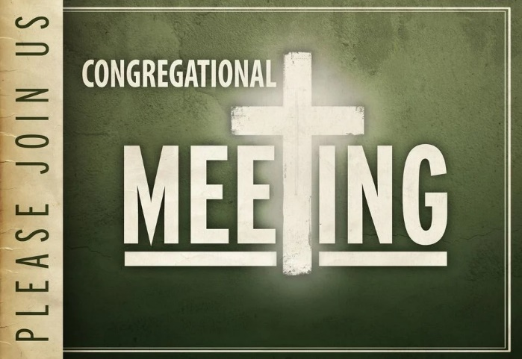

Save the date!
The Annual Congregational meeting is in two weeks,
after church on February 25, 2024.
Hope to see you there!

